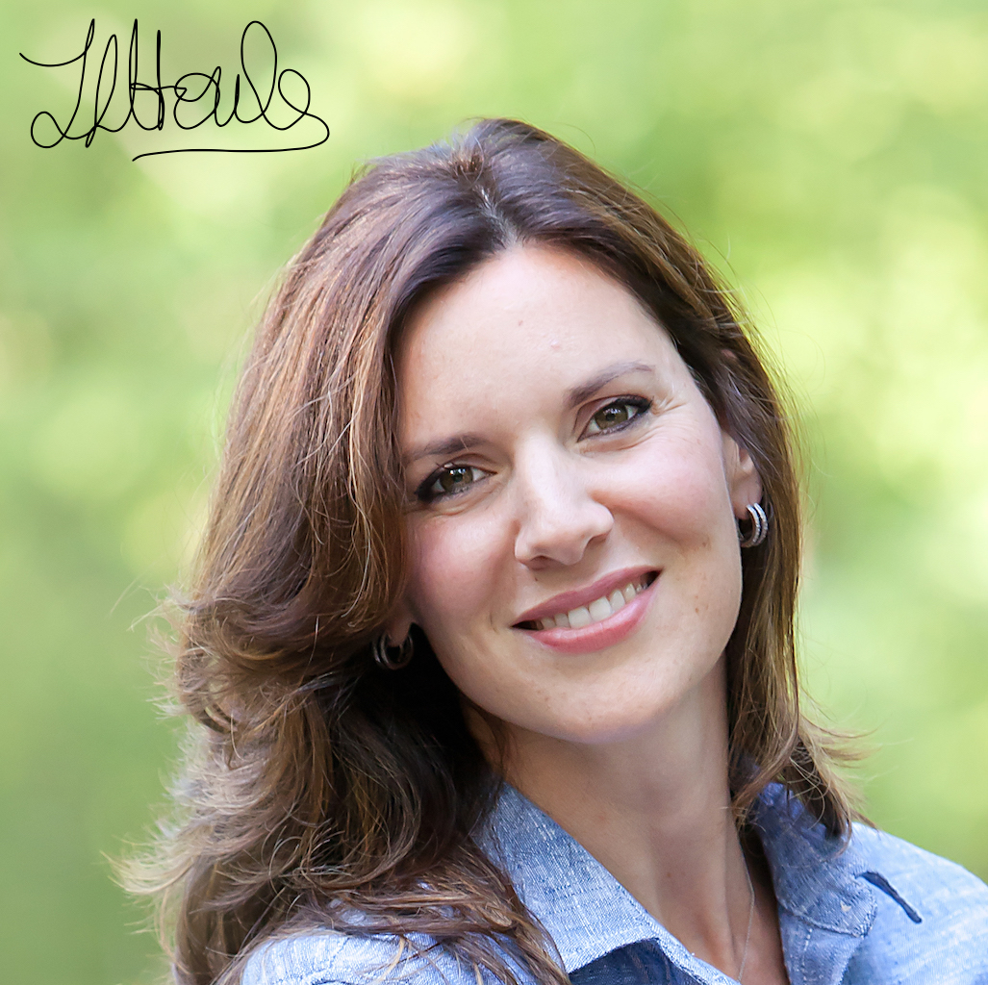

*“Let food be thy medicine and*

*medicine be thy food”*

*Hippocrates*

Hi! My name is Tracy-lynn Houle and I am a **Holistic Nutritionist** from the Canadian School of Natural Nutrition. I am also currently enrolled in the **Academy of Culinary Nutrition** to be accredited with the **Certified Nutrition Expert** title.

I love nutrition and am passionate about working with people who want to improve their health through food.

This all started for me when my son and I were both dealing with food allergies and it caused me to ask the question; “What has happened to our food?”

After years of research, the picture has become very clear. And now I hope to help individuals or families, with a focus on food and health, and getting back into the kitchen!

**SERVICES INCLUDE:**

* **FULL NUTRITION EVALUATION AND CONSULTATION ($150)**
* **HOME KITCHEN MAKEOVER (95$)**
* **LEARN HOW TO NAVIGATE THE GROCERY STORE AND LEARN WHAT THE LABELS MEAN (95$)**
* **MEAL PLANNING WITH THE OPTION OF 3, 5 OR 7-DAY MEAL-PLAN WITH RECIPES, PREP SCHEDULE, AND GROCERY LISTS**

**Book an appointment today!**